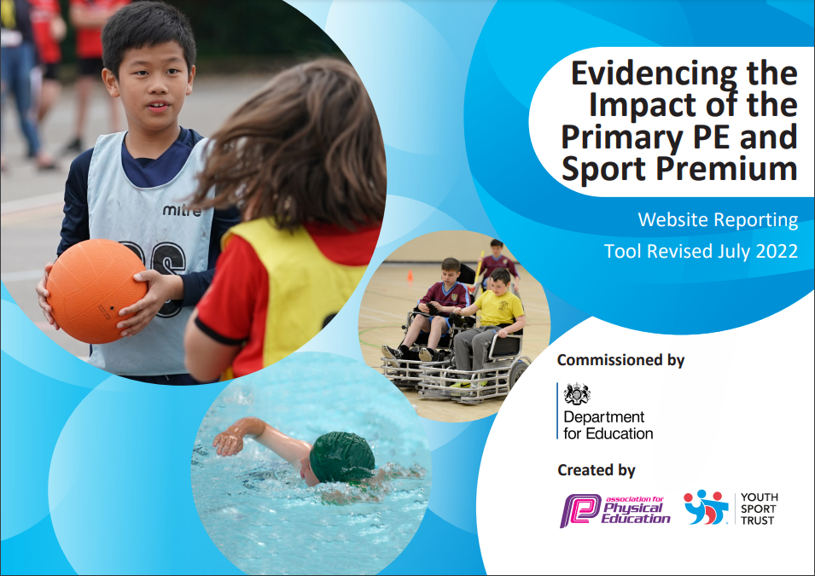
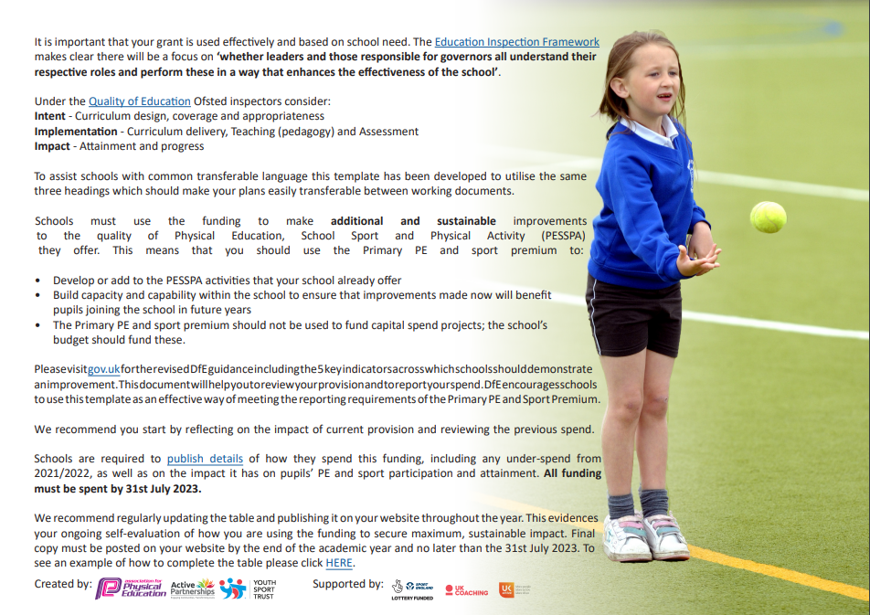
Cavendish Close Junior Academy
Academic Year 2022-23
Rationale

At Cavendish Close Junior Academy we aim to build on children’s natural enthusiasm for physical exploration by providing stimulating, purposeful and challenging experiences through games, dance, gymnastics, swimming, athletics, the daily mile and outdoor and adventurous activities. We aim for as many pupils as possible to engage in activities that promote their physical development including being involved in competitive sports.
We know from evidence that physically active children are not only healthier but do better academically and in life; they are far more likely to be active as adults. The first ten years of life provide children with a blueprint for their adult lives and is the time when they develop the critical fundamental movement skills that act as foundations and building blocks for future activity.

Summary of Proposed activity for 2022-23

Curriculum sports – netball, cricket, tag rugby, rounders, gymnastics, dance, OAA, swimming, athletics and tennis.
OOH clubs – tag rugby, football, netball, drumba, dance, gymnastics, hockey, rounders and athletics.
Fitness – drumba & mile run.
Competitions and festivals – all of the above.

Intended Impact of the Pupil Premium / Sports Funding

It is intended that the above actions will be sustainable over time as they focus on:

- the engagement of all pupils in regular physical activity

- raising the profile of PE and sport across the school as a tool for whole-school improvement

- increased confidence, knowledge and skills of all staff in teaching PE and sport

- broader experience of a range of sports and activities offered to all pupils

- increased participation in competitive sport

Review of our previous strategy academies to add achievements and next steps to the table below

Key achievements to date: | Areas for further improvement and baseline evidence of need:
- The engagement of all pupils in regular physical activity  - We have 2 hours of PE curriculum time for all year groups  - The vast majority of pupils bring their PE kit for lessons  - The embedding of the ‘mile run’ principal to all year groups.  - All classes have activity tubs for playtimes.  - Wow PE experience days.  - The profile of PE and sport is raised across the school as a tool for whole-school improvement  - PE Policy updated and linked to whole school improvement plan.  - Assemblies celebrating sporting success.  - Noticeboards in place displaying certificates and information.  - Yearly fitness check on pupils to identify pupils that needed additional help  - Playtime tubs in increase activity levels.  - Comprehensive program of Physical Literacy developed in school, including training of staff members to deliver an effective program.  - Increased confidence, knowledge and skills of all staff in teaching PE and sport  - Mentor scheme for less confident teachers in all areas of the sporting curriculum.  - Progressive units of Work in place for all PE Lessons across all year groups and between year groups.  - Yearly questionnaire to access staff CPD needs.  - Simple assessment framework for PE in place.  - Lots of opportunities provide to access CPD training  - Broader experience of a range of sports and activities offered to all pupils.  - Range of after school clubs on offer to pupils.  - All year groups have the opportunity to attend sporting events and festivals enabling all children to take part (inclusive of SEN).  - Qualified Sports Coaches running various weekly sports clubs.  - Huge range of school sports clubs for children to attend including, athletics, netball, gymnastics, football, tag rugby, golf and rounders.  - Increased participation in competitive sport.  - Attending a variety of sporting events and competitions run by Derby County in the Community Trust (all year groups).  - Greater percentage of children attending sporting festivals and competitions from all year groups. | - The engagement of all pupils in regular physical activity.  - Lesson times are still often inactive.  - Daily Physical Activity not built into every school day for all pupils – national recommendation for 30 minutes every day.  - The profile of PE and sport is raised across the school as a tool for whole-school improvement.  - More ‘wow’ days to raise profile of PE and encourage more, less physically active pupils into sporting activities.  - Increased confidence, knowledge and skills of all staff in teaching PE and sport.  - Further CPD training needs identified in dance & OAA.  - Broader experience of a range of sports and activities offered to all pupils  - School Sport Council needs to be established to allow pupils to play a role in shaping our sport and physical activity offer.  - Need to access more DCCT festivals for pupils that don’t normally take part – Termly SSP Report.  - More SEND opportunity in competitive sport.  - Increased participation in competitive sport.  - Need to increase number of less physically active children taking part in competitive sport.  - Current intra-competition offer is quite small and needs expanding.  - Use data provided by baseline fitness assessment test to influence and target groups of children.

Academy Swimming Data

Meeting national curriculum requirements for swimming and water safety | Please complete all of the below*:
What percentage of your current Year 6 cohort swim competently, confidently and proficiently over a distance of at least 25 metres? | 57%
What percentage of your current Year 6 cohort use a range of strokes effectively [for example, front crawl, backstroke and breaststroke]? | 54%
What percentage of your current Year 6 cohort perform safe self-rescue in different water-based situations? | 34%
Schools can choose to use the Primary PE and Sport Premium to provide additional provision for swimming but this must be for activity over and above the national curriculum requirements. Have you used it in this way? | Yes/No

Action Plan and Budget Tracking
Capture your intended annual spend against the 5 key indicators. Clarify the success criteria and evidence of impact that you intend to measure to evaluate for students today and for the future.

Academic Year: 2022/2023 | Total fund allocated: £19600 | Date Updated: 15-06-23
Key indicator 1: The engagement of all pupils in regular physical activity – Chief Medical Officer guidelines recommend that primary school children undertake at least 30 minutes of physical activity a day in school |  |  |  | Percentage of total allocation:
 |  |  |  | 25%
School focus with clarity on intended impact on pupils: | Actions to achieve: | Funding allocated: | Evidence and impact: | Sustainability and suggested next steps:
Introduce short bursts of physical activity during lesson time to improve concentration and focus of pupils | - Attend Active Literacy DCCT Workshop - Share at staff meeting.  - Encourage teachers to improve children strength and core by accesses materials. | Included in SSP Affiliation Fee  (£1750 total)  None | Not attended.  Physical literacy programme used for certain SEND children  Impact improved handwriting.  Evidence – books and handwriting assessment after 6 week program.  Drumba programme accessed once per week.  Impacted – improved health and fitness and core fitness  Evidence - fitness assessment tests. | Check next year’s calendar.  Expand programme to incorporate more children.  Continue with contract next year. Expand to include lesson plans.
Continue to change format of mile run to encourage all pupils to engage in increased levels of fitness  To introduce skipping activities to new intake of Year 3 and 4.  To refresh ‘exercise’ boxes for each class to use at playtimes. | - Maintain ‘Cavendish Running League’ for all classes. Bring in ‘Battle of the Bands’ and ‘Average Laps’  - Monitor all class participation  - Share successes and leader board in assembly and on board outside classroom  - Put skipping ropes in all playground boxes.  - Employ ‘Go 4 Skipping’ to deliver skipping sessions and train mini leaders,  - Continue to purchase playground equipment – each class has a box with various equipment to make break times more active and enjoyable. | None  £500  £500 | Impact – children more engaged with ‘mile’ run, fitter and more resilient.  Evidence – Fitness assessment tests.  Impact – more interest in ‘mile’ run.  Evidence – pupil interested.  Not done – Go 4 skipping no longer running.  Impact – limited with no support from ‘Go 4 Skip’ | Continue with programme next year.  Source other skipping companies.  Source other companies and resources.
Develop School Sport Council to involve pupils in improving our physical activity levels at school. | - Identify children in each year group to sit on School Sport Council  - Link School Sport Council with School Council  - Invite SSP to deliver training and support to School Sports’ Council  - Plan and support meetings | None | Impact – school council made decisions on equipment and some events | Continue with half-termly meeting.
Arrange a school based Physical Activity Festival that all pupils can enjoy taking part in. | - Organise within school – one event each term.  Ask SSP to deliver ‘festival’ for a year group. | None | Impact – athletics delivered to Y4. Children enjoyed experience. Some joined athletics club. | More opportunities arrange with DCCT with other year groups.
Train pupils to be Mini Sports Leaders to increase physical activity levels and develop pupils’ leadership skills. | - Arrange training with SSP  - Work with Midday Supervisors to support Mini Leaders  - Celebrate pupils who complete and gain Mini Leaders Award  - Children take charge of organizing skipping during first break.  Laisse with infants to arrange junior leaders to run sessions for infant children. | £250 | Not achieved. | Arrange training for next year.
To introduce ‘Drumba’ sessions, as a tool to increase physical activity for all pupils. | - Purchase ‘Drumba’ package, which includes interactive lessons and all equipment.  - Train staff to deliver ‘Drumba’ sessions.  - Timetable sessions to include –break times, breakfast clubs, lunchtimes and after school times.  - Contact ‘Drumba’ staff to develop whole class lessons to replace existing dance scheme. | £3600 | Impact – all classes do ten minutes of Drumba each week. Fitness levels and enjoyment increased. After school club well attended.  Evidence – fitness test and pupil voice. | Drumba already booked for next year.  New lesson plans accessed to incorporate into the curriculum.
Key indicator 2: The profile of PE and sport being raised across the school as a tool for whole school improvement |  |  |  | Percentage of total allocation:
 |  |  |  | 10%
School focus with clarity on intended impact on pupils: | Actions to achieve: | Funding allocated: | Evidence and impact: | Sustainability and suggested next steps:
Continue to develop school noticeboard in hall and corridors to display information and celebrate achievements in sport to raise the profile of PE and Sport to pupils, parents and visitors. | - Maintain noticeboard outside hall and outside PE coordinators classroom  - Display regularly updated | None | Board maintained and changed regularly.  Impact – pupils feel proud of their schools achievements.  Evidence – sports’ board and pupil voice. | Continue.
To continue to include sporting achievements in the Friday celebration assembly to ensure the whole school is aware of the importance of PE, Sport and Physical Activity and to encourage pupils to take part. | - Weekly assembly slot arranged  - Achievements are celebrated  - Children rewarded for sport/ activity effort/ achievement  - Groups/ classes invite to demonstrate/ perform  - Yearly sporting assembly to celebrate successes  - Provide medals and cups for sporting achievements. | None | Impact – profile of sports and interested increased.  Evidence – pupil voice and sports’ council. | Continue.
Certificates of participation in competitions, festivals and events are displayed in school reception and hall, raising the profile of PE and Sport and celebration pupils participation | - Certificates presented at weekly celebration assembly  - School certificate on display in corridor outside hall  - Results board maintained in down stairs corridor.  - Cups and shields displayed in main reception area | None | Impact – profile of sports and interested increased.  Evidence – pupil voice and sports’ council. | Continue.
To include a sports section in school newsletter re participation in sports events, competitions and festivals, encouraging pupils to take part and informing parents of whole school commitment to PE and Sport | - Sports successes shared on main school letter  - Clubs to be promoted via newsletter  - Newsletter to signpost to community opportunities  - Post achievements on ‘dojo’ account. | None | Impact – profile of sports and interested increased.  Evidence – pupil voice and sports’ council. | Continue.
Update PE, Sport and Physical Activity policies and link to whole school plan, raising the profile of PE and Sport and ensuring pupils get a range of opportunities to be active, healthy learners | - Attend SSP Policy Writing workshop  - Update PE Policy and share with whole staff  - Develop Physical Activity Policy and share | Included in SSP  Affiliation Fee  (£1750 total)  Staff time £500 | Evidence – new PE plan purchased.  PE coordinator received training.  Impact – too early to comment. | Embed new scheme and seek staff views.
Share SSP Termly Report to demonstrate the value school places upon PE, Sport and Physical Activity for their pupils and to celebrate our success/ participation. | - Share termly report with Senior Leaders and Governors  - Review termly reports to continue to build upon success/ participation | Included in SSP  Affiliation Fee  (£1750 total) | Evidence – DCCT report shared with head. | Continue
To carry out whole school assessment tool, to assess the fitness levels of children. | - Premier Sports to carry out whole school fitness test.  - Review whole school assessment report and act upon findings.  - To run activities groups (Drumba) to increase fitness levels. |  | Impact Evidence – each class completed PE assessments | Continue next year and analyze results and compare to previous years.

Key indicator 3: Increased confidence, knowledge and skills of all staff in teaching PE and sport |  |  |  | Percentage of total allocation:
 |  |  |  | 15%
School focus with clarity on intended  impact on pupils: | Actions to achieve: | Funding  allocated: | Evidence and impact: | Sustainability and suggested  next steps:
Ensure school are up to date with key national and local developments in PE and Sport to ensure pupils can benefit from high quality PE and Sport provision | - Attend DCCT Breakfast Briefings and Conference.  Share information from SSP e-bulletin. | Included in DCCT  Affiliation Fee  (£1750 total) | Briefings attended – register  SSP bullets shared with head. | Continue with affiliation – briefings and conferences.
Upskill teachers to improve pupil progress and achievement in PE and sport | - Identify training needs of staff through questionnaires  - Book places on workshops  - Share learning from workshops via staff meeting  - Access resources to support delivery  - Allocate members of staff to mentor. | Included in SSP  Affiliation Fee  (£1750 total)  Cover £500 | 2 members of staff attended NQT program run by DCCT. Staff member’s confidence increased – questionnaire.  2 members of staff attended athletics workshop. Incorporated ideas into lesson plans.  4 members of staff received dance mentoring. Staff members confidence increased – questionnaire | Continue affiliation with DCCT and arrange more training opportunities – identified through staff questionnaire.
Upskill Teaching Assistants to support the delivery of PE and Sport | - Identify training needs of support staff  - Book places on workshops  - Share learning from workshops via staff meeting  - Access resources to support delivery | Included in SSP  Affiliation Fee  (£1750 total)  Cover £400 | As above | As above
Support NQTs through access to ongoing training to equip them with the knowledge, skills and confidence to teach high quality PE | - Book NQT training place(s) via SSP  - Meet with NQTs following training to offer further support  - Organise team teaching to share good practice. | Included in SSP  Affiliation Fee  (£1750 total)  Cover £500 | 2 out of 3 NQT’s received support through DCCT – increased staff confidence (staff questionnaire) | As above
Key indicator 4: Broader experience of a range of sports and activities offered to all pupils |  |  |  | Percentage of total allocation:
 |  |  |  | 35%
School focus with clarity on intended  impact on pupils: | Actions to achieve: | Funding  allocated: | Evidence and impact: | Sustainability and suggested  next steps:
Book a range of competitions for different pupils to enjoy participating in throughout the year. | - Look at competition calendar and book events  - Arrange transport and cover  - Organise training sessions/ club (with staffing)  - Attend events  - Celebrate participation | Included in SSP  Affiliation Fee  (£1750 total)  Transport £4000  Cover £1000 | 55 different competitions booked over all year groups, involving over 70% of pupils in year 5 and 60% of year 6’s.  Pupils feel proud of school and sporting traditions – Pupil voice. | Continue with programmes and adding more dates involving different children.
Attend at least 2 SEND competitions, enabling SEND pupils to access a broader range of activities. | - Work with school SENCO to identify suitable competitions that pupils would like to take part in  - Book competitions  - Arrange transport and cover  - Organise training sessions/ club (with staffing)  - Attend event  - Celebrate participation | Included in SSP  Affiliation Fee  (1750 total)  Transport £500  Cover £300 | No Send based competitions booked, as complexity of provision this year. | Look to book next year, as provision changing.
Identify 3 additional competitions for pupils to represent their school in. | - Book competitions  - Arrange transport and cover  - Organise training sessions/ club (with staffing)  - Attend event  - Celebrate participation | Included in SSP  Affiliation Fee  (£1750 total)  Transport £500  Cover £300 | Sports’ council identified three new competitions – hockey, orienteering & Summer Sports Festivals | Continue to look at programme of sports offered by DCCT and look to offer a wider variety of opportunities.
Develop School Sport Council to allow pupils to play a role in shaping our sport and physical activity offer | - Arrange ongoing training/ support from SSP  - Identify children to sit on School Sport Council  - Attend meeting  - Reward pupils for contributing | None | Sports council members voted for and meetings taken place. Made decisions on playtimes, playground toys and competitions. | Arrange at least bi-termly meetings.
Identify at least one ‘WOW’ day to inspire the children into sport. | - Identify a suitable visitor through sports’ council  - Arrange  - Link to a club or activity to maintain legacy. | £750 | Cyclo-cross arranged for Year 5 and 6  Cyclo cross competitions arranged through DCCT – 1st place in grass track cycling. | Identify other WOW days to inspire children.
Maintain and develop a range of out of hour’s clubs to lead into a pathway for competitive sport and sport in the community. | - Maintain existing clubs  - Ask school council to identify new clubs/sports to offer as a school.  - Identify needs per year groups.  - Contact sports coaches to assist in delivery of clubs. | £5000 | Athletics, netball and football clubs have provided children with opportunities to join local clubs | Explore link with local cricket clubs.
Key indicator 5: Increased participation in competitive sport |  |  |  | Percentage of total allocation:
 |  |  |  | 10%
School focus with clarity on intended  impact on pupils: | Actions to achieve: | Funding  allocated: | Evidence and impact: | Sustainability and suggested  next steps:
Increase pupils’ participation in the School Games programme. | - Identify and book School Games events  - Arrange transport  - Organise training sessions/ club (with staffing)  - Attend events  - Celebrate participation | Transport – as above | Participation up from 40% for Y5 and Y6 to 65% | Increase percentage by signing up for different sports identified by school council.
Book a range of competitions for different pupils to take part in and represent their school, including SEND pupils and other disadvantaged groups. | - Work with School Sport Council to identify competitions that pupils would like to take part in  - Book competitions  - Arrange transport  - Organise training sessions/ club (with staffing)  - Attend event  - Celebrate participation | Included in SSP  Affiliation Fee  (£1750 total)  Transport - as above | More competitions booked that deliberately target SEND pupils and PP children – Summer Sports Festival | Continue to look for opportunities in DCCT programmes.
Attend at least 1 new competition for each year group, increasing participation in competitions | - Work with School Sport Council to identify competitions that pupils would like to take part in  - Book competitions  - Arrange transport  - Organise training sessions/ club (with staffing)  - Attend event  - Celebrate participation | Included in SSP  Affiliation Fee  (£1750 total)  Transport – as above | Y5/6 Summer sports, Y3/4 Summer Sports, Invasion games festival Y3/4 and Y5/6 booked. | Continue to highlight opportunities.
Target Year 3 and 4 pupils to take part in more competitive sport opportunities | - Ask children what competitions they would be interested in  - Book competitions  - Arrange transport  - Organise training sessions/ club (with staffing)  - Attend event  - Celebrate participation | Included in SSP  Affiliation Fee  (£1750 total)  Transport – as above | 3 more competitions booked this year. | Continue to highlight opportunities.
Introduce intra-competition challenges to encourage pupils to enjoy taking part in school based competitions | - Liaise with DCCT to plan intra-competition programme and gain ideas  - Identify staff to deliver/ support competitions  - Involve Mini Leaders in supporting intra-competitions  - Arrange dates for competitions  - Celebrate participation | Included in SSP  Affiliation Fee  (£1750 total) | New field event added to Sports Day offer. | Look for opportunities each term.
Use the School Sport Council as a tool to identify additional competitions that pupils would like to access | - Share DCCT Calendar with School Sport Council  - Ask pupils to identify events that they would like to access  - Ensure as many pupils as possible can benefit from competition calendar  - Book events |  | School council identified Summer Sports Competition as possible success. | Continue.

Approval route:
Sports Premium Lead: Mark Bowen | Date: 19-07-23
Principal: Michelle Tague | Date: 21–07-23
Trust Leader: | Date:

